Ideation Phase Empathize & Discover

Date | 18 February 2026
Team ID | LTVIP2026TMIDS66141
Project Name | IntelliSQL: Intelligent SQL Querying with LLMs  Using Gemini Pro
Maximum Marks | 4 Marks

Empathy Map Canvas:
An empathy map is a simple, easy-to-digest visual that captures knowledge about a user’s
behaviours and attitudes.
It is a useful tool to helps teams better understand their users.
Creating an effective solution requires understanding the true problem and the person who is experiencing it. The exercise of creating the map helps participants consider things from the user’s perspective along with his or her goals and challenges.

Example:

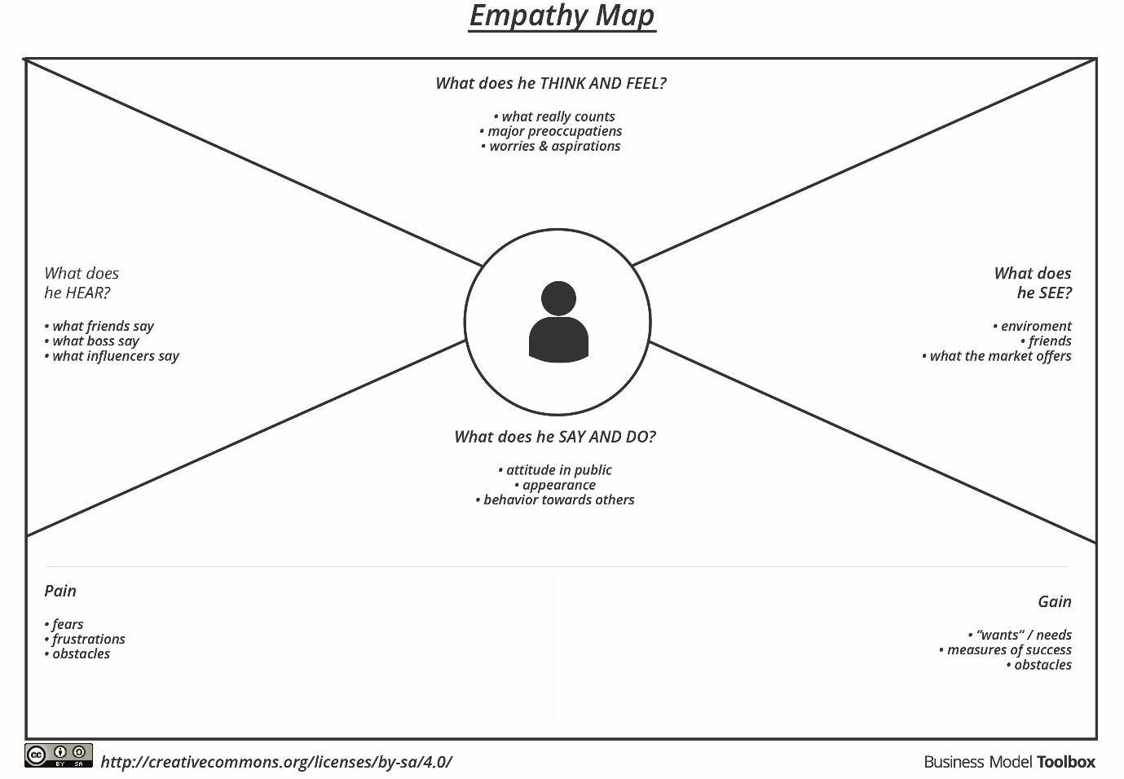

Reference: https://www.mural.co/templates/empathy-map-canvas

Target User: College Student

Section | Details
WHO are we empathizing with? | Alex, a 28-year-old academic administrator who manages student records. Alex is data-reliant but has no background in computer science or programming.
What does she need to DO? | Extract specific insights from the STUDENTS table—such as marks, class distributions, and company placements—effortlessly and intuitively without writing code.
What does she SEE? | Complex database schemas that look intimidating. Traditional SQL tools (like Oracle SQL Developer) that require coding expertise. A modern, professional IntelliSQL interface with a dark theme and green accents.
What does she SAY? | I wish I could just ask my database a question in plain English. Why does retrieving student marks have to be so technical?  I need an intelligent platform that understands my intent.
What does she DO? | - Navigates to the "Intelligent Query Assistance" section of the app.  - Inputs natural language questions like "Show me students with marks more than 80."  - Reviews results in a structured table format generated by the Gemini Flash model.
What does she HEAR? | - Use IntelliSQL; it uses advanced LLM capabilities to write queries for you.  - The IT department is backlogged; you'll have to wait a week for that report.  - AI like Gemini is revolutionizing how we interact with SQL.
PAINS | - Frustration with the "technical barrier" of SQL syntax.  - Dependency on technical staff for simple data retrieval.  - Fear of making errors in manual SQL commands.  - Time wasted on repetitive, manual data sorting.
GAINS | -An effortless, intuitive interface for database interaction.  - Real-time SQL generation and execution.  - Accurate trend analysis and syntax suggestions.  - Professional-grade performance optimization.

Key Takeaways:
The primary goal of IntelliSQL is to bridge the gap between human thought and database logic. By providing an intelligent query assistant, we empower users like Alex to become self-sufficient, turning natural language into actionable data insights

